Snowflake and Einstein Analytics

|  |  |
| --- | --- |
| **Summary** | To set up Snowflake Account and to learn Einstein Analytics |
| **URL** | <https://s3.amazonaws.com/snowflake-workshop-lab/Snowflake_free_trial_LabGuide.pdf>  <https://docs.snowflake.com/en/user-guide/sample-data-tpcds.html>  <https://salesforce-trailblazer.com/snowflake-einstein-analytics/>  <https://www.salesforceblogger.com/all-about-saql/> |
| **Tools** | SnowFlake, Salesforce Einstein Analytics |

# Snowflake Account Setup

Data Loading Tutorial

Sample Data : TPC-DS:

Einstein Analytics:

3 Lesson Learned

# Snowflake Account Setup

# 

# 

# 

# Data Loading Tutorial

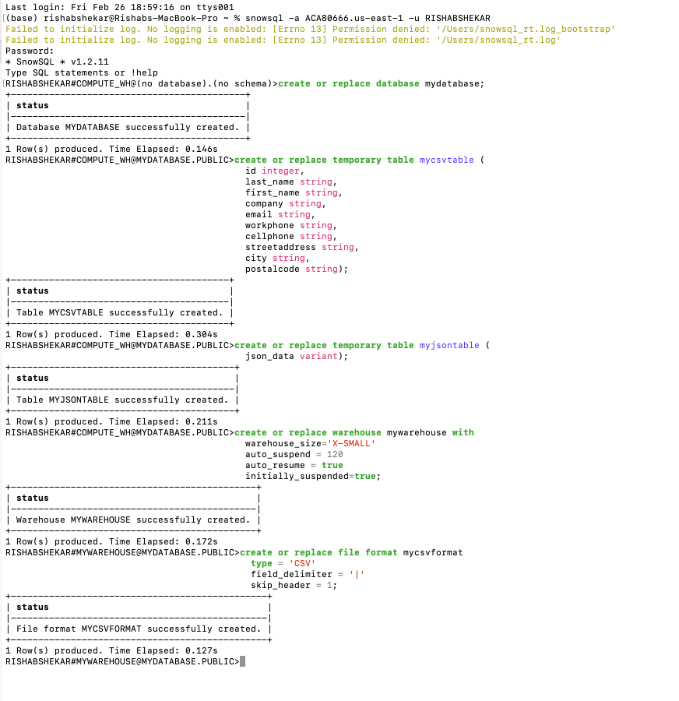

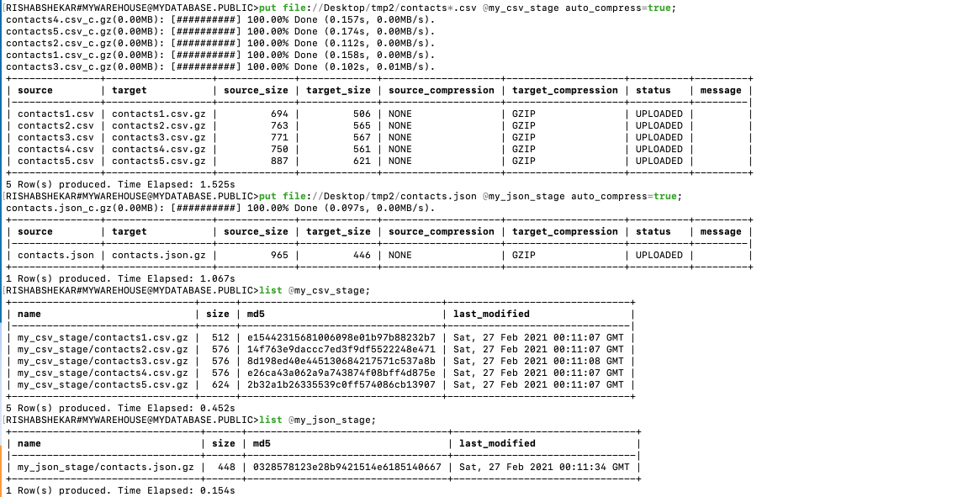

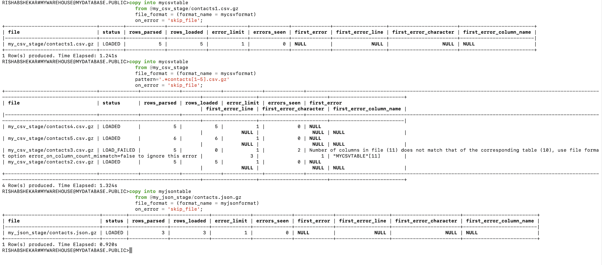

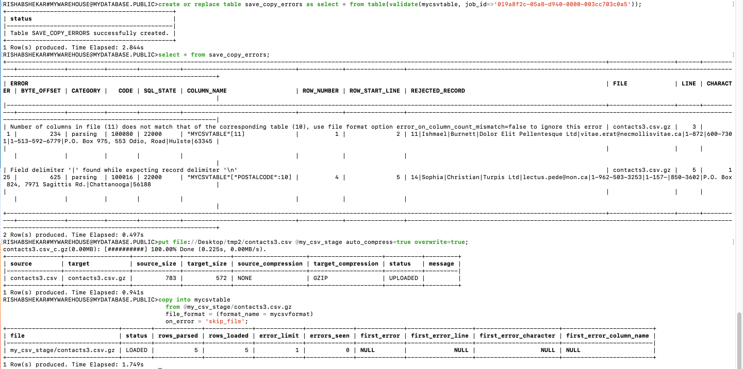

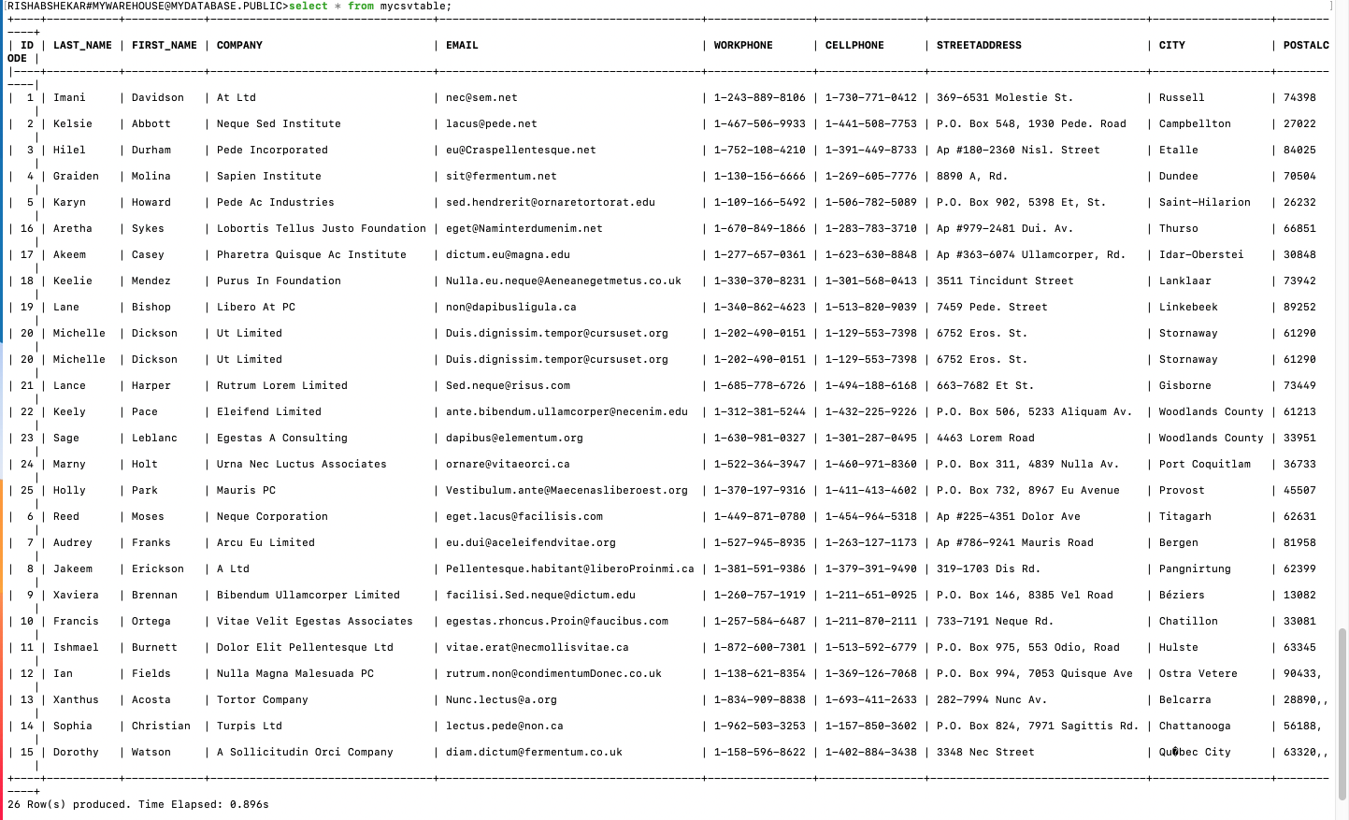

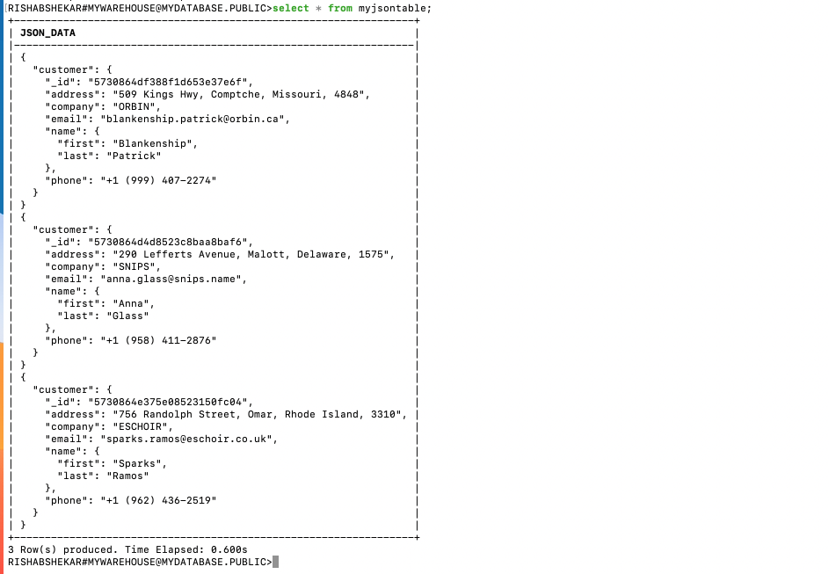

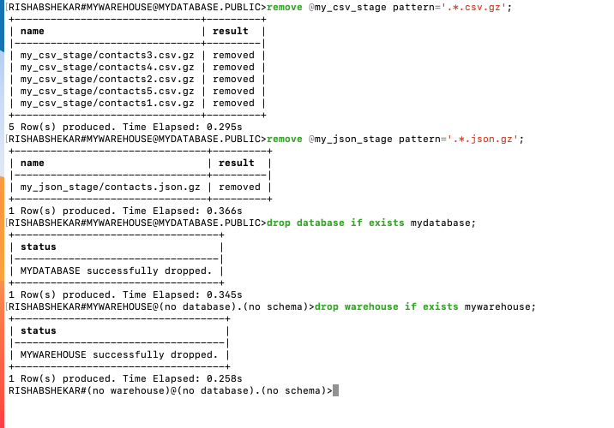

# Sample Data : TPC-DS:

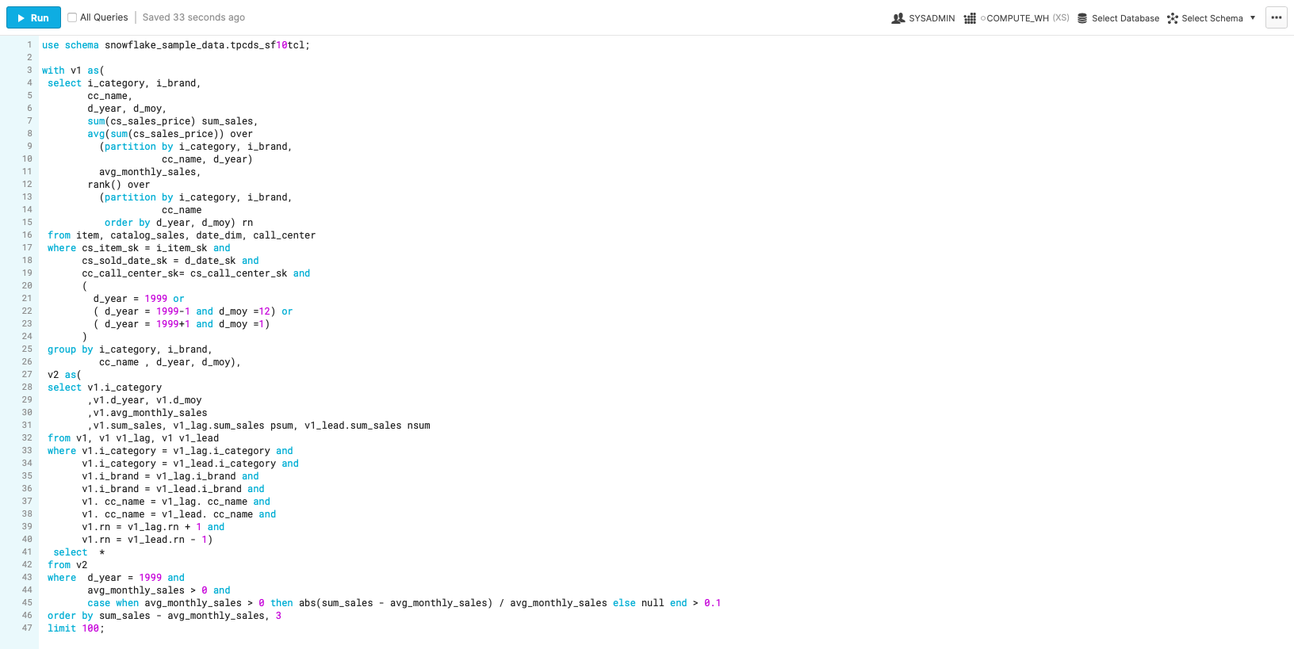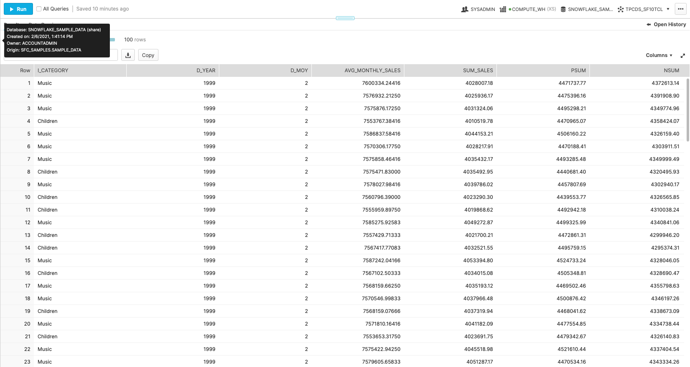

# 

# 

# 

# Einstein Analytics:

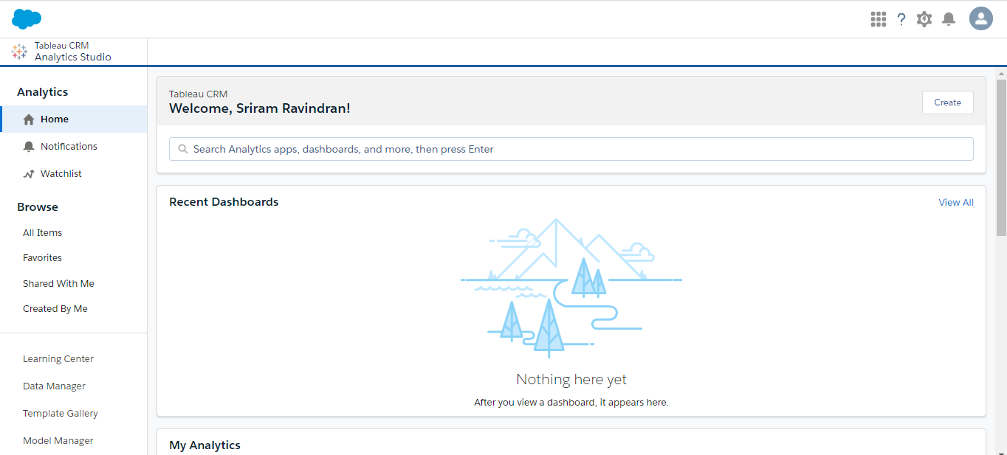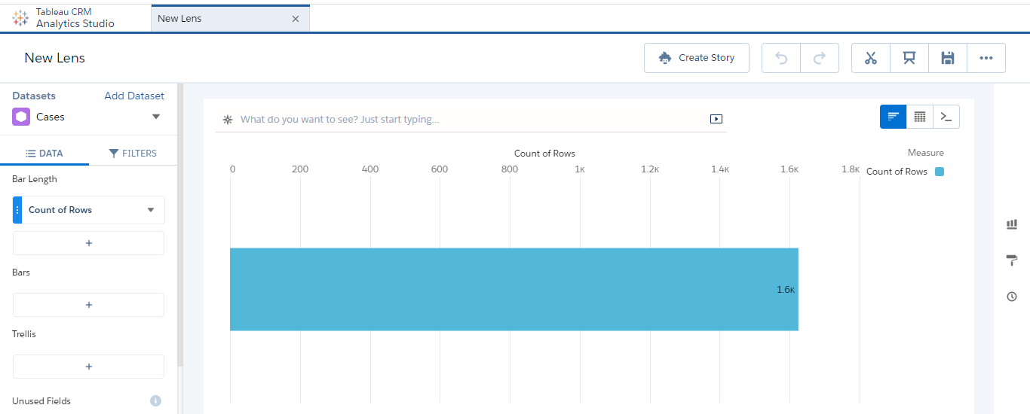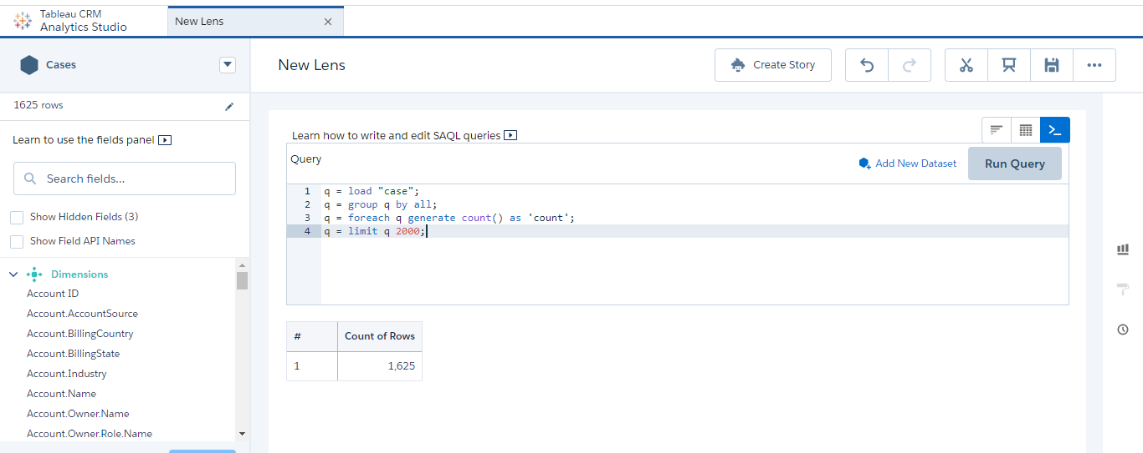

# 3 Lesson Learned

* Snowflake manages all aspects of how the data is stored: organization, file size, structure, compression, metadata, and statistics.
* Data can be loaded faster and high volume of queries can also be run.
* Salesforce Einstein Analytics evaluates large data sets, obtains crucial insights, recommends beneficial actions, and operates tasks that used to need manual effort by the workforce.